EFECS2019 Pilot Lines Impact workshop

* [PREVIOUS](https://www.ecsel.eu/news/doris-vierbauch-elected-chair-ecsel-ju-public-authorities-board)

* [BACK TO ALL ARTICLES](https://www.ecsel.eu/node/14)

* [NEXT](https://www.ecsel.eu/news/project-impact-video-productive40)

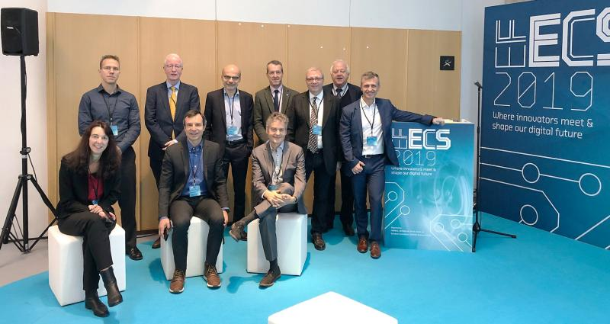

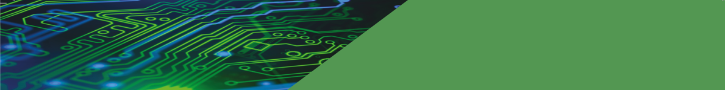



The EFECS co-located workshop “ECSEL Pilot lines success stories and impact” was successfully organised by STMicroelectronics in cooperation with its partners CEA- LETI,   TU Darmstadt, SOITEC, Global Foundries, LYNRED, Robert Bosch GmbH on Tuesday November 19th at Helsinki.

It provided a unique opportunity to share with EFECS participants the results of these ECSEL pilot lines and a common vision defined by 3 key attributes: Scale, Persistence and Excellence.

* **Scale**, by mobilizing large communities with a mix of companies and public research organizations and reinforcing partnerships. They had the critical mass to work along the technology/supply chain -From materials to product- and along the value chain to accelerate the co-innovation and market adoption and strengthen demand in Europe
* **Persistence**and **continuity**, as these projects belong to a pipeline of ambitious projects around technologies such as FDSOI, RFSOI and memories for MCUs.
* These projects provided Excellence as the different examples of success stories can testify (link to presentations)

**The presented projects were:**

* PANACHE: Developed an embedded flash technology platform dedicated to the design of innovative microcontrollers and their manufacturing.
* REFERENCE:  Developed innovative RF-SOI substrates & technologies (including move to 300mm) enabling the realization of integrated front-end modules, and system level demonstrators for cellular, aeronautics, paving the way to 5G.
* POLIS: Developed differentiating technologies enabling the prototyping of a large range of innovative sensors and breakthrough micro-displays such as: Low-cost Infrared thermal sensors for consumer markets, high luminance low power micro-displays for augmented reality applications, gestures recognition sensors and depth-map camera based on Time-of-Flight, etc.
* Lab4MEMS II: Developed innovative technologies on advanced Micro-Opto-Electro-Mechanical Systems. This Pilot line realized a variety of devices including optical switch, array of micro-mirrors, optical cross-connect, lasers and micro lens amongst others.
* WAYTOGOFAST : Developed the competitiveness of FDSOI by offering higher performance node architectures in 22FDX and 28FDSOI and their substrate manufacturing.